Name _________________________________ Density Notes

Period ________ Date __________________ Earth Science

* ______________________________________________________________________________________________
* Which of the following is the most dense?

A B C D

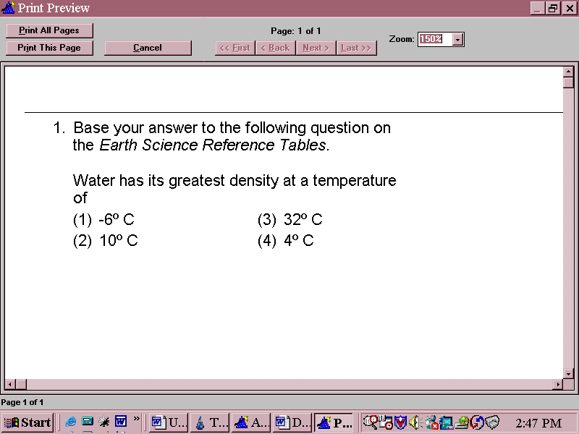

* ______________________________________________________________________________________________
  + ____________________________________________________________________________________
* **As the temperature of a substance increases, ______________________________________________________________________________________________**
* **As the temperature of a substance decreases, ______________________________________________________________________________________________**
* Floating and Sinking
  + ____________________________________________________________________________________
  + ____________________________________________________________________________________
* If the object and the fluid are equally dense, ______________________________________________________________________________________________
* For a floating object, the lower the density, ______________________________________________________________________________________________
* **Ice _______________ in water because _______________________________________________**

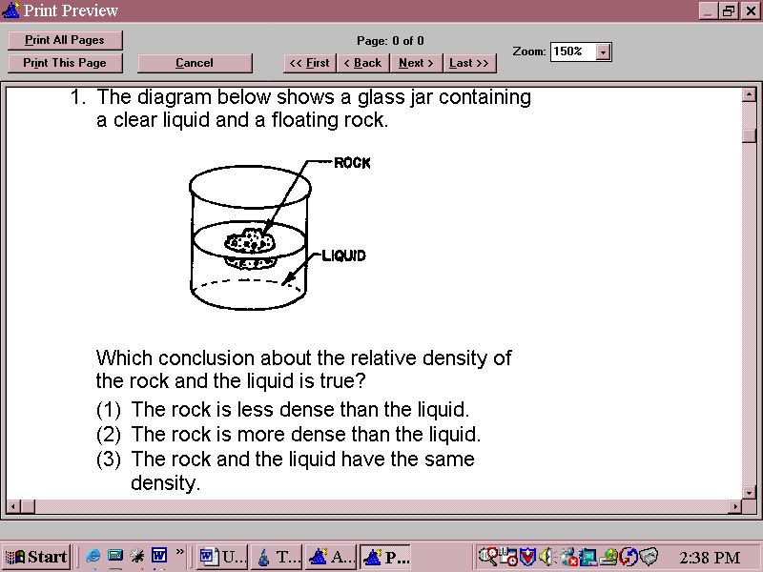

* Calculating Density
  + The higher the number, _______________________________________.
  + You do not have to remember the formula because ________________________________________.
* **Example # 1** The mass of an object is 13.5 grams and its volume is 4.2 milliliters. Round your answers to the nearest tenth.

1. Write the formula:
2. Substitute the numbers:
3. Do the math:
4. Units/Rounding:

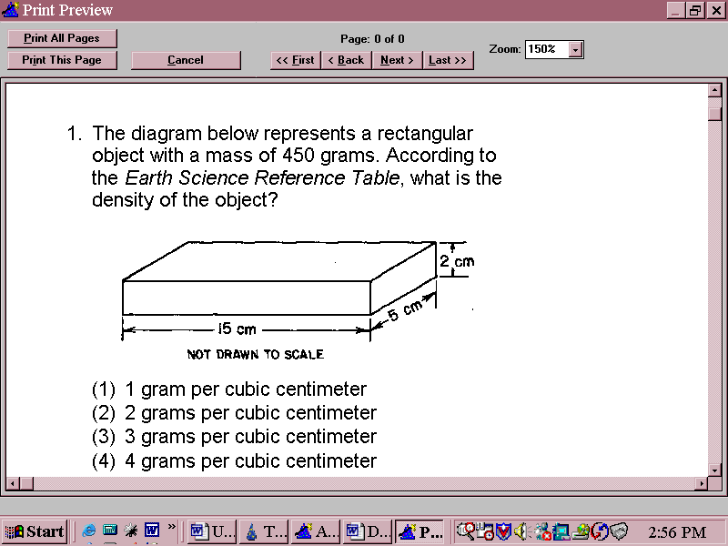

C:\Users\1441140\AppData\Local\Microsoft\Windows\Temporary Internet Files\Content.IE5\WE1OSFQ2\MC900390704[1].wmf

* KEY IDEA: **_______________________________________________________________________________________________________**.
* If you cut an object in half its density will **___________________________________________________.**
* Prove it to yourself and calculate the densities of a wood block and half of the wood block:
* Whole Wood Block Half a Wood Block

Mass = 20.0 grams Mass = 10.0 grams

Volume = 40.0 milliliters Volume = 20.0 milliliters